Week 4
Class Diagrams
Justina Nangolo
Youtube Video

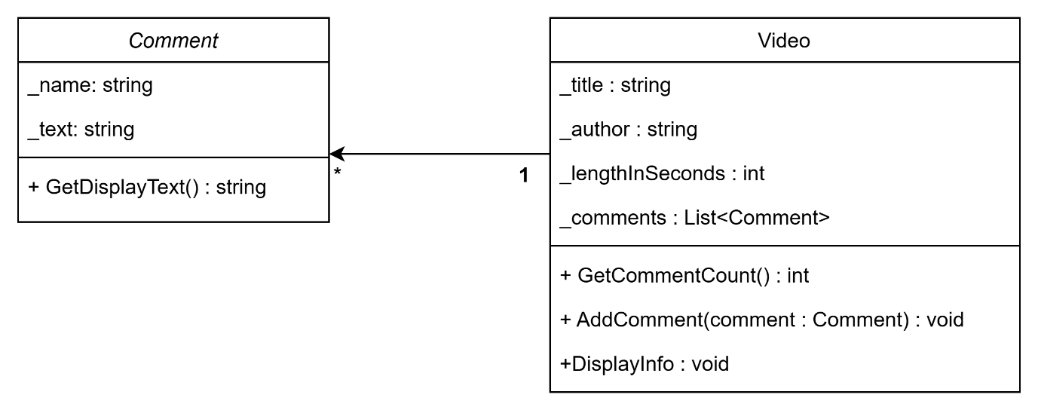

Online Ordering Program
